**Appendix E**

**Title**: User Manual for *CompareTheHealthcare.com*

**Relevance**: This document contains a formal user guide and descriptions on how to use the web portal and what a user can get out of it. This includes screenshots of the portal in various use cases, details on the information provided and the purposes behind the software.

**Welcome**

Thank you for choosing *CompareTheHealthcare.com*. This manual should act as a guide for using the web portal and searching for the procedure that’s right for you. *CompareTheHealthcare.com* gives financial and locational information on over 1.2 million individual procedural results, helping you to shop around for the deal that’s right for you.

**Searching**

When launching the website, you will get this page:

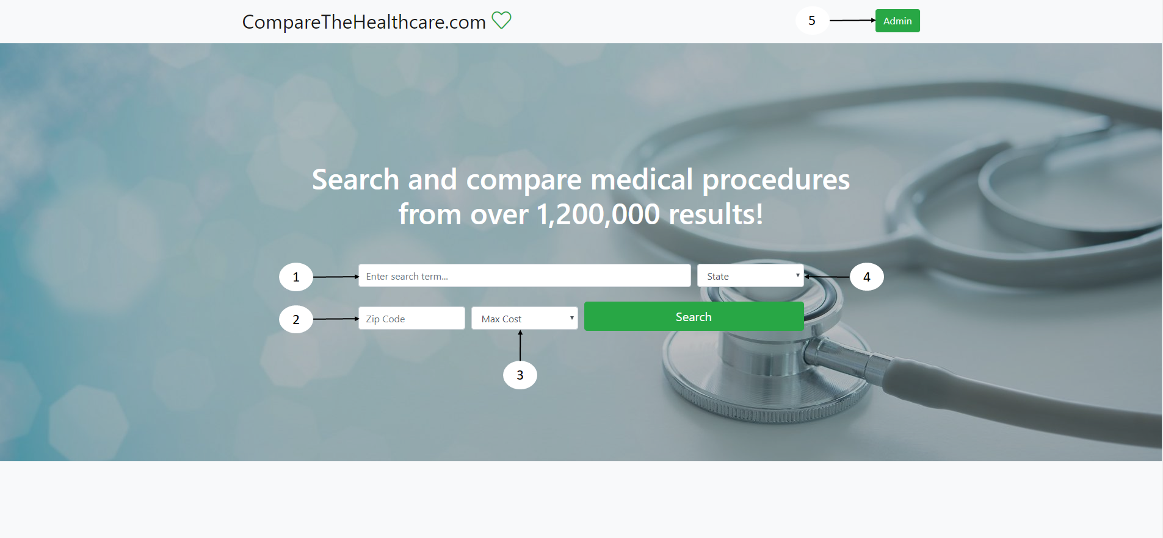

1. Enter procedure or body part term
2. Enter your zip code
3. Enter maximum cost willing to pay for procedure
4. Enter state where you would like to undertake the procedure
5. Admin login page

The search can be used for browsing procedures by name or keyword, allowing for specification on which state to search for. When entering a search term, allow for your keyword to resolve to a result from the dropdown. If nothing is suggested, your search will not display any results. Entering a search state and your zip code and cost you are willing to pay are entirely optional but may help you narrow down your results.

Allowing the website to access your location is entirely optional but highly recommended. Your browser will ask to use your location when you first visit the site: press “Allow” or “Yes” to let this go ahead. The purpose of this is to find the closest procedures for you and is used in the ranking of results.

**Results**

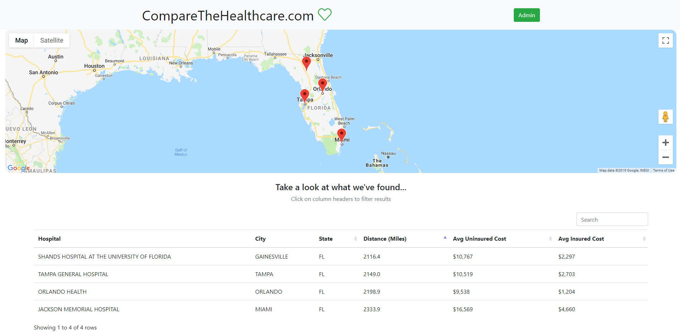

When a search is carried out, a successful one returns results in a format as above for a search for “Caesarean Section”. A table displays a list of results in ascending order of distance from the user’s location, along with details for the hospitals providing that procedure and the average uninsured and insured price of undergoing that procedure in the last year. The map above the results shows the geographical location of the hospitals currently being displayed in the list, relative to where the user is located.

**Further Details**

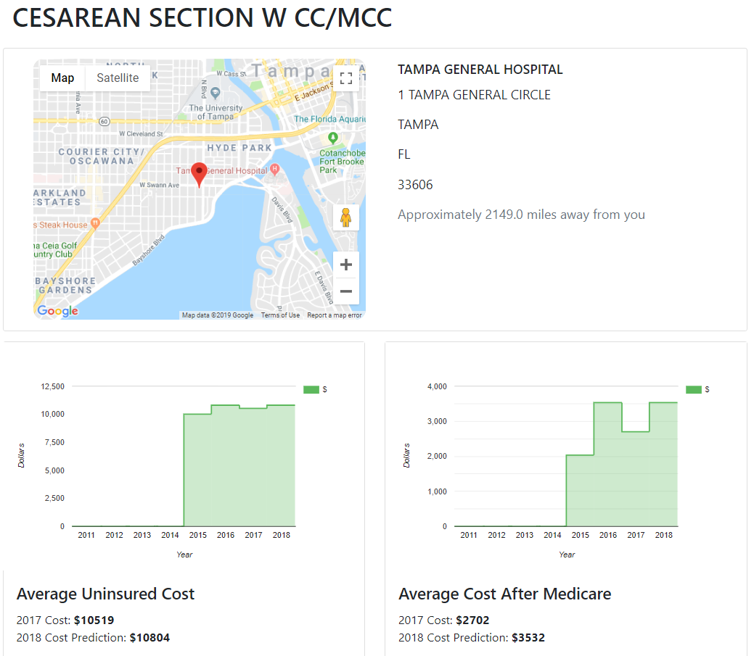

Clicking on one of the results in the table brings up further details of the procedure at that hospital. The address of the hospital is displayed alongside a localised map of that hospital. Graphs below give a visual timeline of how the cost of that procedure has changed over the years, allowing for trends to be drawn from the data. Last year’s cost of the procedure is displayed along with a prediction for the cost in the next year.

**Example Usage**

You are a Californian citizen insured by Medicare suffering from some pain in your chest. By entering “chest” into the search, a list of search suggestions are displayed. You click on one of them, which mentions procedure “313 - CHEST PAIN” - exactly what you need! You have allowed your location so you need only enter “ANY” state and you specify your maximum budget as $3000. Upon hitting search, you receive the following page.

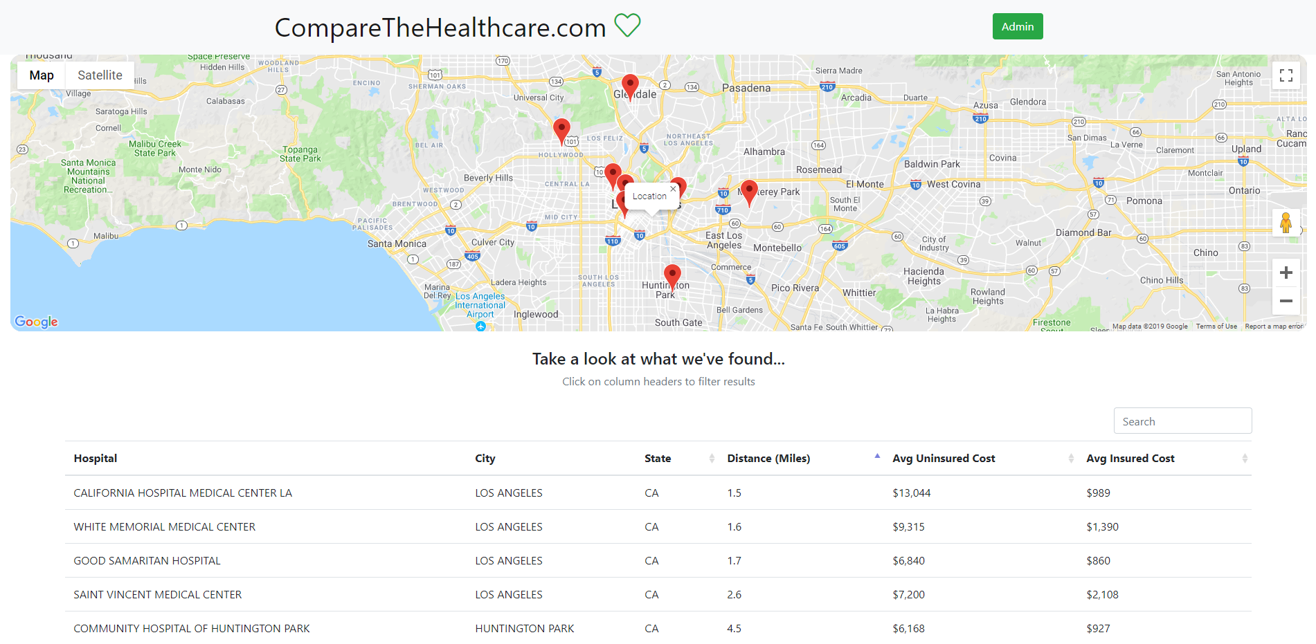

You are presented with a list of hospitals offering the procedure you need, in ascending order of distance from your location. Comparing the results and sorting the table by clicking on the column headers, you can see that the Good Samaritan hospital, 1.7 miles away from you is perfect and affordable at $860. You click on that result and are presented with the following page:

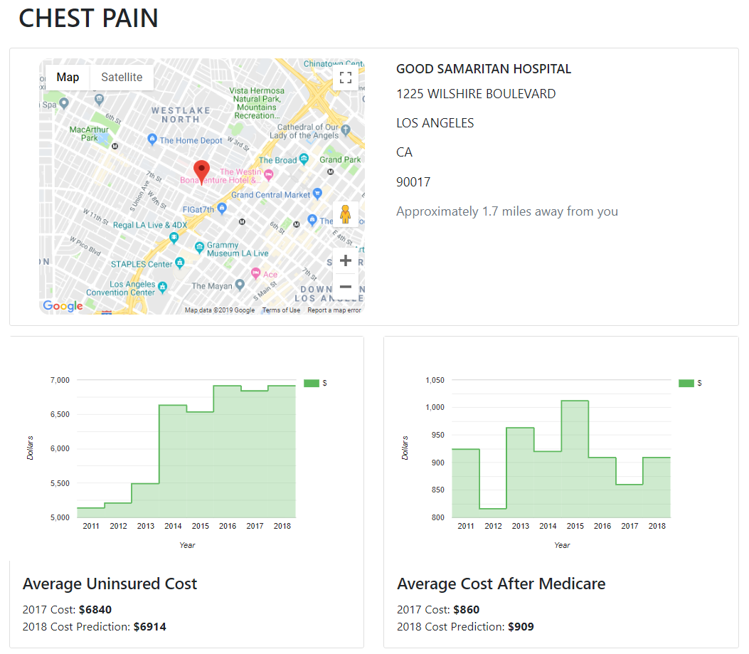

Here you can see the exact address and location of the hospital. Below are graphs of the change in price of this procedure at this hospital over time, allowing you to visualise trends in the data. The graphs also show a prediction for what this price will be in the next year.

**Contact Page**

Clicking the “Contact” button at the bottom of each page will send the user to this page:

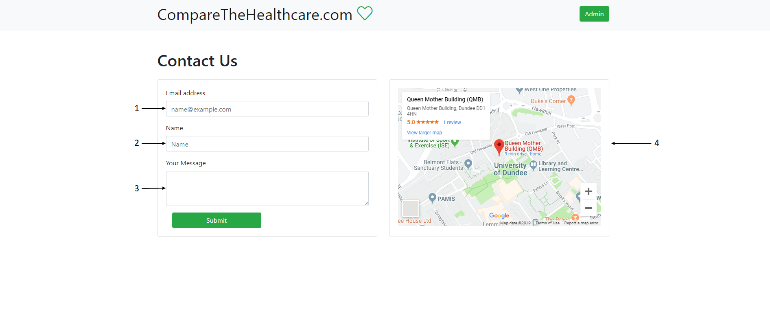

1. Enter user’s email address
2. Enter user’s name
3. Enter user’s message
4. Map showing the location of “CompareTheHealthcare.com”

The contact page can be used for contacting the website administrators. It is useful for asking website questions, reporting issues and suggesting features you’d like to see in the website.